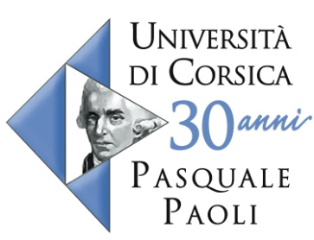

Proposal for a 6 months fixed term contract
Year 2013-2014 - Engineer or equivalent

Context
The UMR CNRS 6134 SPE has been working for more than 15 years on forest fire modeling. One of its research areas is the development of measurement devices using vision and allowing the estimation of geometrical characteristics of fire such as its position, speed, area and volume.

Mission
In the group « Vision » of the « Forest fire » project, you participate in the development of methods and algorithms for the registration of 3D geometrical data including using multimodal data analysis.

Competences, skills required
Engineer or equivalent
image processing, vision, C++, matlab

University of Corsica
The University of Corsica is a French public university with about 4,400 students.

The « Forest fire » Project
The « forest fire » project is one of the five projects of the joint unity of research (UMR SPE) “Sciences for the environment” 6134 CNRS – University of Corsica. It includes about twenty researchers in chemistry, physics, computer science, ecology and image processing working on the study and the modeling of forest fires.

Salary : 1,439 €/month
Location : UMR CNRS 6134 SPE - Université de Corse, Campus Grimaldi, 20250 Corte
Duration : 6 months between September 2013 and May 2014

Contact person
Dr. Rossi Lucile
Head of the « vision» group
E-mail : lrossi@univ-corse.fr
Phone: +33 (0)6 10 48 28 82
Websites : http://spe.univ-corse.fr/spip.php?rubrique172 and http://www.firevision.fr

Required documents
CV and e-mail introducing yourself to lrossi@univ-corse.fr

